Go to goal robot

Team 12 Shyamprasad V Atri,Spandana K R,Parikshit B G,Kartik M Karur

The robot starts at 0,0 and wants to go to 5,5

After 10000 iterations with proportional gain the robot wanders around every ware and reaches upto 4.1,4.1

from scipy import \*

from pylab import \*

from scipy.integrate import odeint

import math

init=[0,0]

final=[5,5]

vel=-6

phid=math.atan((final[1]-init[1])/(final[0]-init[0]))

t=0

start=[vel,vel]

phi=math.atan((final[1]-start[1])/(final[0]-start[0]))

omg=-3

phi=phi\*omg

print(phi)

k=1.5 #pid term

x=[]

y=[]

while(phi!=phid and t<100000):

curr=[vel\*math.cos(phi),vel\*math.sin(phi)]

phi=omg\*(math.atan((final[1]-curr[1])/(final[0]-curr[0])))

err=phid-phi # error calculation for pid

omg=k\*err # PID with only p taken to account

phi=phi\*omg

x.append(curr[0])

y.append(curr[1])

t=t+1

plot(x,y,[-5,5],[-5,5])

show()

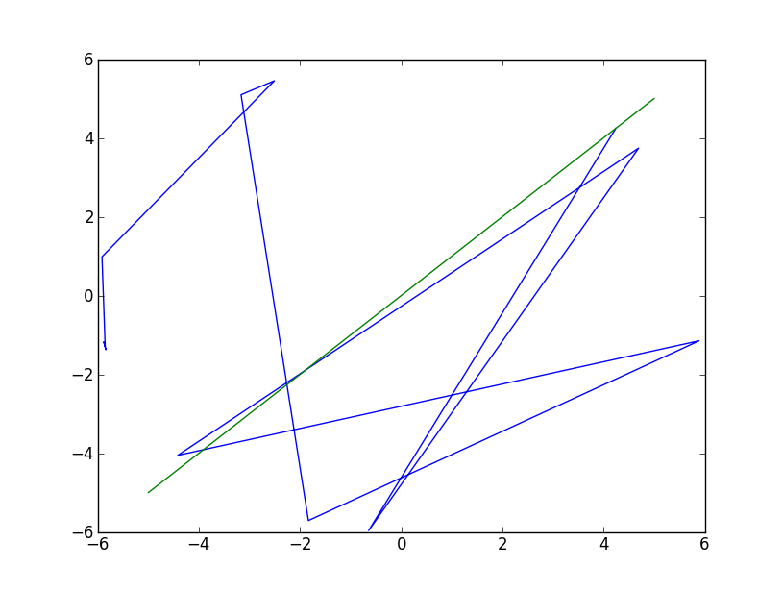

The blue lines represent the path taken by the robot